1. There are two types of data at the most fundamental level – categorical (qualitative) and numerical (quantitative)
2. Scales of measurement of data are: nominal, ordinal, interval and ratio. This is important to know, so we can summarize the data.
3. When the data of a variable consists of labels or names used to identify the characteristic of an observation, the scale of measure is ***nominal*** scale. It could be numerically coded, based on some convention. Examples: Name, Board, Gender, Blood Group etc. No ordering can be applied on nominal variables. One can’t also perform arithmetic/comparison operations on it.
4. When data exhibits properties of nominal data and the order or rank of data is meaningful, the scale of measurement is considered ***ordinal*** scale. It could be numerically coded, based on some convention. It can be used in comparison operations, but not in arithmetic operations. Difference between the possible pairs of values is not the same. Examples: Percentiles, Customer rating of services – Excellent (2), Good (1), Bad (0).
5. If the data have all properties of ordinal data and the interval between values is expressed in terms of fixed unit of measure, then the scale of measurement is ***interval*** scale. Interval data is always numeric, and can be used in arithmetic/comparison operations. However, ratio between possible pairs of values is not comparable, since there’s no absolute zero. Example: Temperature measured in degree Celsius.
6. Note that, temperature specified as comfortable/uncomfortable is a nominal data, while temperature specified as cold, warm and hot is ordinal data. Temperature measured in degree Celsius is interval data. However, it’s incorrect to say that outdoors is twice as hot as indoors.
7. If the data have all the properties of interval data and the ratio of two values is meaningful, the scale of measurement is ***ratio*** scale. Examples: Height, Weight, Age, Marks, Temperature measured in Kelvin scale.
8. 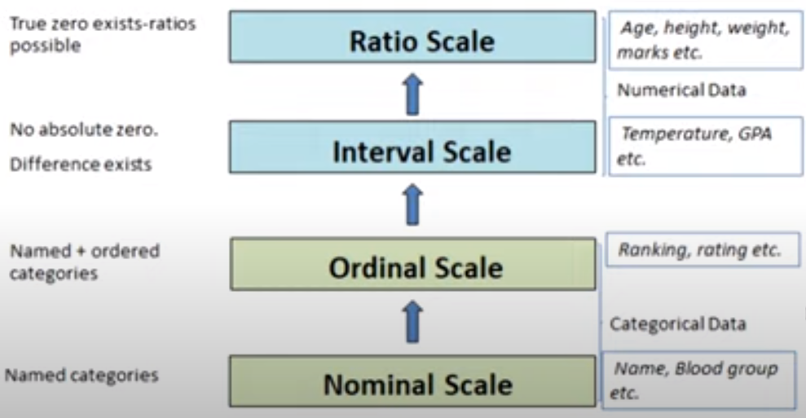
9. Variables with an interval scale of measurement may be converted into a ratio scale of measurement using subtraction operation.
10. Mathematical/logical operations supported on variables using various scales of measurement:

|  |  |  |
| --- | --- | --- |
| **Scale of measurement** | **Mathematical operations** | **Logical operations** |
| Ratio | +, -, *, / | >, <, == |
| Interval | +, - | >, <, == |
| Ordinal | None | >, <, == |
| Nominal | None | == |